

INFORMATION SHEET FOR GUESTS

Thank you for completing your registration for six group vocal lessons with Circular Keys Chorus. This information will also be emailed to the email address you have provided during
registration. Although Circular Keys Chorus is not affiliated with any particular religious group, we are very lucky to have found excellent rehearsal space at the lovely premises of St Joseph’s near Bella Vista. We hope you will find the following information useful.

Address: St Josephs Conference Centre, 64 MacKillop Drive, Baulkham Hills, NSW 2153

Parking: There is parking at the rear of the centre – enter down the entrance driveway, following the road curving right towards the large group of buildings and the reception area. Keep right at the road divide, and drive around the back to the car park. Please do not park across driveways as departing staff need clear access 24 hours.

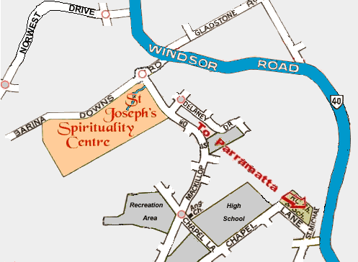

Registration: 7th August 2013 at 7pm outside the Pacifica Room, St Joseph’s. A member of the chorus will be at front reception to meet and greet, and escort you to our rehearsal rooms. At registration we‘ll assign you a voice part and give you a folder with instructions, sheet music and a CD to assist you to learn the songs.

Lessons: Wednesday 7th August 2013 and each Wednesday afterwards, to Wednesday 11th September. The Graduation Concert will be held on September.?

Times: From Wednesday 14th August, arrive by 7:15 pm. Rehearsal starts at 7:30 pm and runs to 10:00 pm, followed by supper.

Contacts: If you have any questions, or need help to find us on the night, phone Judith on 0418 214 189 or Alison on 0418 623 446.

Program:

For Week 1: 7:00 – 7.30 pm Registration
7:30 – 7:40 pm Physical warm ups
7:40 – 7:45 pm Welcome
7:45 - 8.05 pm Vocal instruction with Vicki and the chorus
8:05 – 10:00 pm Rehearsal of song with chorus
10:00 – 10:30 pm Supper

Topics: Week 1: Posture: the basis for all good singing
Breath: the fuel for singing
Week 2: Phonation: creating the sounds of music
Resonation: creating good vocal vibes
The “inside smile”
Week 3: Articulation: creating words that communicate
Fundamentals of vowels, diphthongs, consonants and dynamics
Week 4: Coordination
Review, questions and answers
Week 5: Fundamentals of Barbershop
Performance skills
Dress rehearsal for Graduation Concert?

What to bring:

- Water
- Comfortable clothing and shoes
- The sheet music you received when you registered and a pencil
- You might also like to bring a cassette recorder, MP3 recorder or similar, if you have one.

Please don’t wear perfume to rehearsal, as some people have allergies which affect their singing.

We look forward to seeing you there!



