Fabulous

Spring Fair

**Where:** St Joseph’s, 64 Mackillop Drive, Baulkham Hills

**When:** Sunday 25th September, from 10am to 3.30pm

**How much:** $5 for adults, including refreshments (children free)

**Come visit our beautiful rehearsal venue and spend a relaxing hour or two browsing**

**a wonderfully diverse collection of stalls, including:**

* Phoenix Trading - beautiful paper craft, including greeting cards and gift wrapping
* Home-made preserves and herb vinegars from Liz’s Gourmet Kitchen
* Individually created turned wooden bowls and home wares from Wim’s Workshop
* Fair Trade stalls, including Nurturing Threads, Destiny Rescue and Ethica Accessories
* CKC stall of scarves, socks, bags & pens, all with a musical theme
* Aromatherapy Works – lotions, oils and a 15 minute Bowen massage
* Maddison Avenue candles including Kajita brand (proceeds to Japan’s Tsunami victims)
* Elegance Et Tu – made to order jewellery , Swarovski crystals, scarves & bags
* We Only Do Delicious – gourmet foods, kitchen linen, handmade teapot cosies & teapots
* Plant stall including tropical fruit trees and succulents
* Sausage barbecue for rumbling tummies
* Another of CKC’s renowned raffles with great prizes to be won

**In both the morning and afternoon, ‘Addiction’ will present a fashion show of 50%-75% reduced designer clothes for men, women and children –**

**including Wish, Cooper St, Mossimo and Elly M**

**Any queries, please phone Ann on 0407 215 162 or go to circularkeys.org**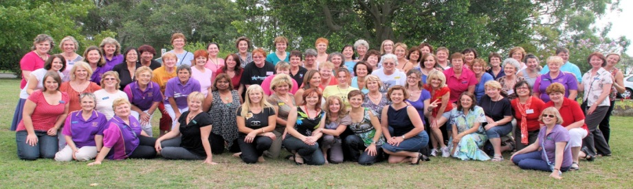

**By attending this Spring Fair, you will help Circular Keys Chorus get to Denver, Colorado in October 2012, where they will be Australia’s representatives in the International SAI Women’s Competitions**