CKC Management Team Zoom Minutes Friday 10th January 2025

**Chairperson:** Rachael Moessis

**Minutes:** Anne Harris

| **Item**  **No.** | **Item** | **Discussion** | **Action** | **By Whom** | **By When** |
| --- | --- | --- | --- | --- | --- |
| 1. | **Attendance via Zoom**  **Apologies**  **Meeting commenced:** | Chairperson Rachael Moessis  Secretary Anne Harris  Membership Frances Gurto  Treasurer Susan Kelly  Performance Jane Masters  Marketing/PR Jen Kumar  Team members  Director Vicki Dwyer  Pippa Anderson  Di Jenkins  Crystal Forbes  7.40pm |  |  |  |
| **2.** | **Acceptance of minutes** | Moved: Rachael  Seconded: Frances |  |  |  |
| **3.** | **Business Arising** |  |  |  |  |
| 3.1 | Chorus Cultural project | Mission statement **“We unite through music creating a harmonious space where voices blend, friendships frow and artistry thrives”**  Further discussion re chorus culture planned for the meeting next week with Jan Cawley on 14/2/25 at Vicki’s. | Insert mission statement into Dec newsletter | Rachael | Completed  Ongoing |
| 3.2 | Member recruitment | New singers always welcome” to be pinned on Instagram  Invite Macquarie Uni groups - discussed that this is difficult as their group doesn’t start back until the Feb/March. Decision made to leave at the moment. | Instagram inserts  Invitation to singers | Jen  Vicki | Completed  Hold over |
| 3.3 | BHA Competition 2025 Eastern region Nationals | This will be held on 24/5 in Sydney- venue unknown at this stage. It would be great for the whole chorus to have this experience. | Put in CKC calendar | Rachael | ASAP |
| 3.4 | Portfolios, Procedures and Handovers | Each committee member to compile a short list of the responsibilities and processes of their individual roles  that would be helpful for any new future committee members  Set up new document section for committee portfolios on CKC website | Compose a short list | All committee members  Rachael | ASAP  ASAP |
| **4**. | **Ohio planning** |  |  |  |  |
| 4.1 | Ooters/Brindabella Guide | CKC Brindabella Ooter guide.  After discussion it was decided to use an adapted smaller version that Di already has already compiled. | Complete shorted Ooter guide  Send to Rachael to distribute  Distribute package to Ooters | Di  Di  Rachael | ASAP  ASAP  ASAP |
| **4.2** | Forward planning | Team to inspire members and Ooters  Newsletter articles  Di liaising with Scotsdale regarding rehearsal space and risers  Housing or accommodation package for Ohio has been received and chorus needs to put in their preferences. for motels. Forms due back 12/2/25.  The allocation will be made by international. Members will soon need to start thinking about their commitment and accommodation buddies.  We have 3 confirmed Ooters at the moment. The cost for them would be $450 which would cover the 9 months. A bond of $50 to cover the costume.  Discussed sending a personal email invitation to past members to join us going to Ohio.  Directors School soon and Vicki will request directors to extend an invitation to their choruses for Ohio  Development of a digital DL flyer re Ohio to be used for advertising. This could also be used in the “Baby come Back” contest through SAI. | Ohio newsletter in SCB  Submit accommodationforms  Email to chorus members  Send email  Discussion with chorus directors  Digital flyer | Rachael  Di  Rachael/Di  Di  Vicki  Vicki  Jen | Hold over  Ongoing  Ongoing  12/2/25  ASAP  ASAP  Mid January  ASAP |
| 4.3 | Compulsory rehearsal attendance for Ohio | Monthly first Saturday rehearsals  Potential October family show 11th October.  Hold over further discussion until meeting with Jan Cawley. | Check access to St Josephs | Rachael | Completed  Hold over |
| 4.4 | St Joseph room hire, dates and spaces | St Joseph’s not available 22nd January for rehearse for Australian Day. Crystal offered her home at 17 Hadden Close Glenwood- many thanks Crystal  1-22nd October not available to St Joseph’s. ? for new date with Bec 27-28th September | Chorus members to attend  Dates to be confirmed | Crystal  Bec | 22nd Jan  As possible |
| 4.5 | T- shirts and jacket options | Jacket feedback from Frances- difficult for our chorus to access clothing company at a good price.  Continue research for jackets through Hills Uniform etc |  | Crystal | Ongoing |
| **5.** | **Correspondence** | 1. Coastal Acapella- emails re hire of risers/sharing rehearsal rooms 1/2/25 2. St Joseph’s re rehearsal dates on Wednesdays, Saturdays in 2025 3. Fair trading re new Rules/ Constitution 4. SAA re members not receiving OzChords (Crystal, Cathy H, Spring, Phillipa) 5. SAI receipt $500 3/12/24 6. SAI emails re Housing Packet 31/12/24 and 10/1/25 |  |  |  |
| **6.** | **Ratifications** | None |  |  |  |
| **7**. | **Reports** |  |  |  |  |
| 7.1 | Financial | (See report below)  Accepted: Rachael  Seconded: Crystal  New members form for International fee payment  Discussion re reducing costs for the chorus due to lowered numbers. There was a loss of $3500 for the 2024 year.  Main costs include St Joseph’s room hire. Some discussion re asking St Joseph’s to reduce costs. Difficulties of changing venue as they also provide space for our risers and costumes.  Need to concentrate on increasing chorus numbers and fund raising and limiting coaching costs. |  | Sue, Frances | Completed |
| 7.2 | Music team | New ballad -Always on My Mind (ballad)  Many thanks to Vicki for the learning tracks for the chorus  We listened to a new uptune “I Just Found Out About Love”  Vicki has already started with the learning tracks and is gifting the normal price for this to the chorus- many thanks Vicki.  To research songs appreciation with SAI/SDE song evaluation data base | Check data base | Rachael | ASAP |
| 7.3 | Membership | (See report below)  Now 33 members  Jane Masters has resigned this month and will become Chapter at Large  Francis reports that new members need to pay International fees.  “That’s what I like about you” encourager used at Christmas party.  ‘” Baby Come Back” contest with SAI.  Entries to be completed by 3/2/25  Discussed that SAA need to notified re new members joining | Notify SAI  Pay International fees  in January  Develop flyer and collate responses  Email SAA | Frances  Susan  Social committee  Frances/Jen  Frances | ASAP  Completed  Completed  3/2/25  ASAP |
| 7.4 | PR/Marketing | (see report below)  Discussed the need for a flyer to be used for Directors/Ooters re CKC in Ohio.  Jen showed some great examples for a new logo for CKC. Many thanks Jen for your great ideas. | Develop flyer  Develop logo | Jen  Jen | ASAP  Ongoing |
| 7.5 | Performance | (See report)  Jane presented her last report as she is resigning from chorus. Many thanks for the enormous effort and commitment you have given Jane.  Send change of contact details from Jane to Crystal to Parramatta council. c/c Crystal  Australia Day gigs Parramatta council on 26th  First roaming gig- call time of 7.45am with 8.15-9am singing  Request has come through from Parramatta Council for a second roaming performance 10.15-11am. Discussed that this would be put to chorus members.  Create second performance gig for CKC website  Coloured shirts/ black pants/ skirts for Australia Day.  Contact other event managers re change of contact person from Jane to Crystal | Email council  Contact Parramatta council re our fee  Email members re availability for second performance  Performance on CKC website  Email | Jane  Crystal  Rachael  Di  Crystal | ASAP  ASAP  ASAP  ASAP  As possible |
| 7.6 | Fund raising | Bunnings BBQ’s:  9th February and 12 April 2025.  BBQ equipment now with Rachael and to go to Crystal  Square given to Crystal  Doris Ward award given to Rachael  New Paint and Sip at Tallawong  Contact list for fund raising and performances included in report | Discuss with social committee | Jen | Hold over |
| **8** | **New Business** |  |  |  |  |
| **8.1** | New Performance co-ordinator and Fundraising Chair | Crystal has volunteered to step up into the performance/ fund raising role. Many thanks Crystal. She will ask for assistance as needed. |  |  |  |
| **8.2** | Australia day rehearsal | St Joseph’s is not available on 22nd January for rehearsal. To be held at Crystal’s 17 Hadden Close Glenwood |  |  |  |
| **8.3** | CKC constitution update | Emails back and forth |  |  | Completed |
| **8.4** | Meeting with Jan Carley | 14th January at Vicki’s 7.30pm for management and music team to discuss chorus culture, etc |  |  |  |
|  | Meeting closed | 11.05pm |  |  |  |
|  | **Next meeting**  **7th February 2025 7.30pm** | **Venue: Rachael 17 Cavendish Street Pennant Hills** |  |  |  |

REPORTS

FINANCIAL

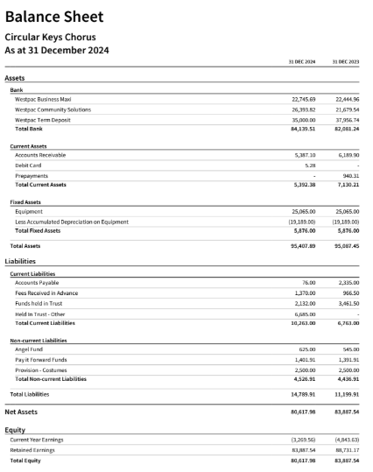

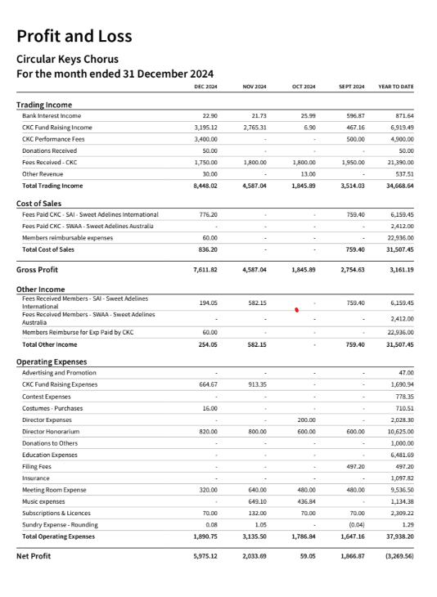

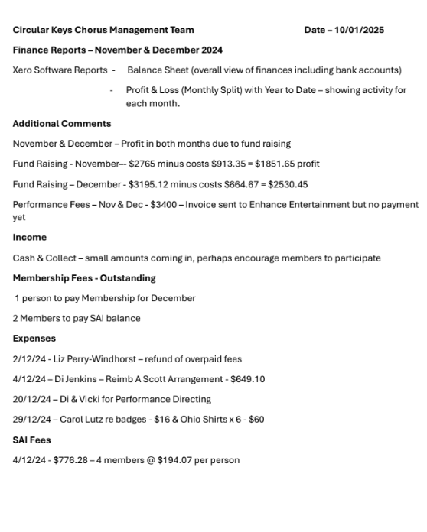

MUSIC REPORT

None

MEMBERSHIP REPORT

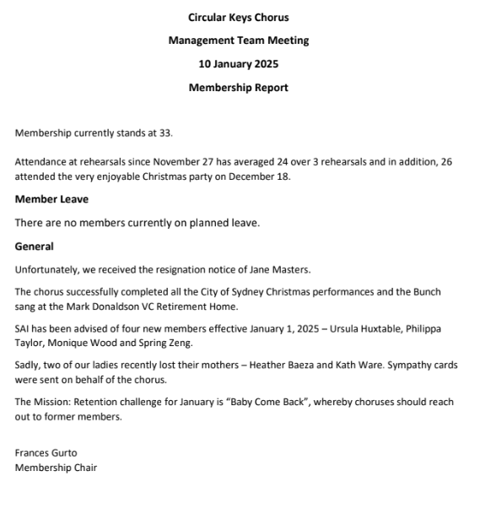

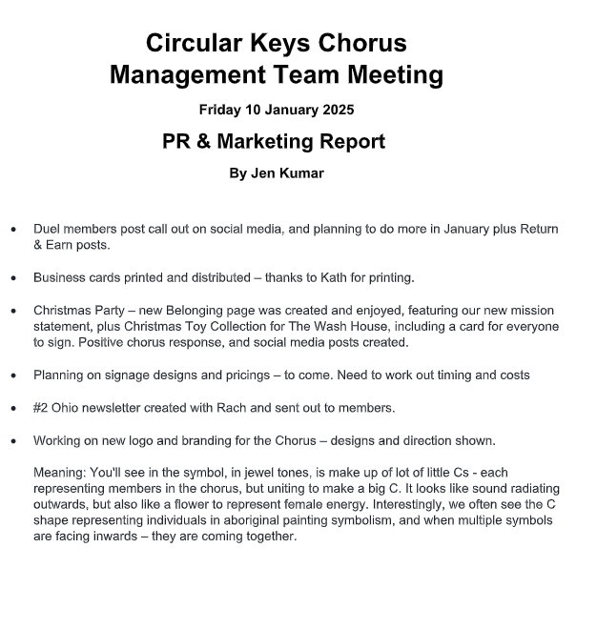

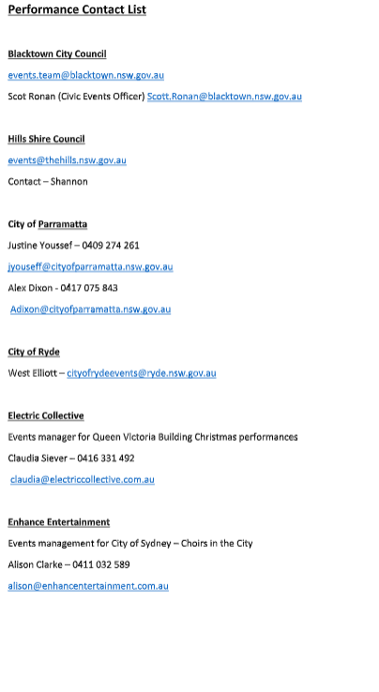

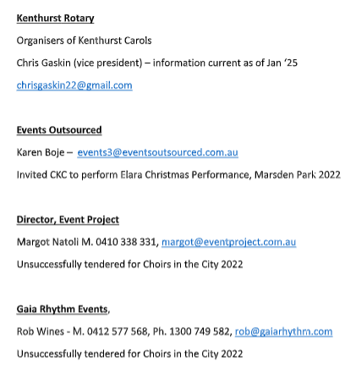

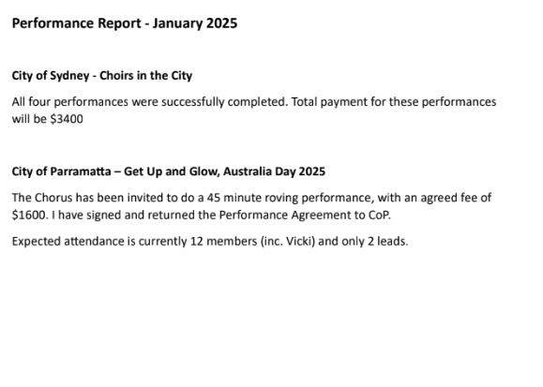

FUNDRAISING

None