CKC Management Team Zoom Minutes Friday 18th October 2024

**Chairperson:** Rachael Moessis

**Minutes:** Anne Harris

| **Item**  **No.** | **Item** | **Discussion** | **Action** | **By Whom** | **By When** |
| --- | --- | --- | --- | --- | --- |
| 1. | **Attendance via Zoom**  **Apologies**  **Meeting commenced:** | Chairperson Rachael Moessis  Secretary Anne Harris  Treasurer Susan Kelly  Membership Frances Gurto  Performance Jane Masters  Marketing/PR Jen Kumar  Team members  Crystal Forbes  Director Vicki Dwyer  Pippa Anderson  Di Jenkins  7.35pm |  |  |  |
| **2.** | **Acceptance of minutes** | Moved: Jane  Seconded: Crystal |  |  |  |
| **3.** | **Business Arising** |  |  |  |  |
| 3.1 | Chorus Cultural project | Many thanks to Crystal for using ChatGPT to develop a potential mission statement.  “Our mission is to deliver outstanding musical performances while upholding the values of education, respect, and commitment. We create a fun and inclusive environment where each woman’s voice is celebrated, and excellence is achieved through hard work, mutual support, and a competitive spirit that drives us to perform at our best.”  Jen suggested incorporating “We create a fun and inclusive environment where **each woman is valued** **and her’s voice** is celebrated” maybe in the last sentence.  To further develop mission statement after discussion with Vicki and Di then present to whole chorus for input- suggestion to have one short and one longer mission statement.  Present mission statements to chorus | Finalise mission statements  Via SCB | Crystal, Vicki and Di  Rachael | Hold over until next meeting  December |
| 3.2 | Update on Changes to NSW Incorporation Rules | Susan having difficulties with emails and has not received the form she needs to complete for public officer.  .  Chorus to vote on acceptance of NSW Incorporation Rules and changes. | Resend form via different email address  Article in SCB  Voting | Rachael  Rachael | ASAP  6th November |
| 3.3 | Member recruitment/banners/ Taster Nights | Banner placements in Hornsby Shire.  Potential members not to receive paper copies of music to take home due to copyright restrictions.    Music folders and music for potential new members  As taster nights have been cancelled any potential interested new members can always attend a Wednesday night rehearsal.  “New singers always welcome” to be pinned on Instagram  Discussion if Vicki could extend the invite for Ooters to her mixed chorus and Macquarie Uni singing group | Investigate changeable banners  Send Hornsby link to Jen  Article in SCB  Visitor books to be updated.  Instagram inserts  Invitation to singers | Jen  Rachael  Rachael  Ann Thompson  Jen  Vicki | Ongoing  Completed  Completed  Ongoing  ASAP  ASAP |
| 3.4 | Sharon Cartwright visit | Not progressing at the moment | Email Sharon | Rachael | Completed |
| 3.5 | IBOD voting | For whole chorus | Set up voting process | Rachael | 6th November |
| **4**. | **Ohio planning** |  |  |  |  |
| 4.1 | Ooters/Brindabella Guide | Use of guide for CKC Ooters, add recommendations for Sat/ weekend rehearsals.  Continue to advertise CKC Ooters for Columbus Ohio 2025. We have had 3 Ooters wanting to join already.  General discussion re Ooter payment to chorus- in Brindabella Guide approximately $650 which includes joining fee, and membership for 10 months. Other costs would include? costume (if not able to be provided), shoes, special t shirt., make up. | Adapt Brindabella guide for CKC  Facebook, Friends of CKC, Instagram | Crystal  Jen | ASAP  Ongoing |
| **4.2** | Basic details for members for forward planning | ?? team to inspire, encourage and motivate members and new Ooters.  Discussed interesting topics and places to see that could be included in next month’s Ohio newsletter - crosswords, weather expectations, room buddies, getting passport ready, Armish area closeby, covered bridges, flight time to New York and other tourist places. | Ohio newsletter in SCB | Rachael | November |
| 4.3 | Dates for compulsory rehearsal attendance | Monthly first Saturday rehearsals in 2025 for those attending Ohio. Anonymous donor paying for weekend rehearsals at St Joseph’s- many thanks!!  St Josephs have been approached re dates for Saturday rehearsals in 2025- we have not heard back. | Check access to St Josephs | Rachael | ASAP |
| **5.** | **Correspondence** | * Dianne James re Rules for Incorporation * Sharon Cartwright re delaying chorus workshop * Sweet Adelines Australia re Director’s School |  |  |  |
| **6.** | **Ratifications** | None |  |  |  |
| **7**. | **Reports** |  |  |  |  |
| 7.1 | Financial | (See report below)  Susan reports that at the moment we are just maintaining costs for St Joseph’s and Vicki. All other costs are coming out of previous years funds. |  |  |  |
| 7.2 | Music team | (see report)  New arrangement from Adam Scott -Always on My Mind (ballad) maybe arriving at the end of October.  Pay for license to arrange  Remind members that Christmas risers are needed for new Christmas songs. Music can be held for new members.  Discussion re seeking clarification with Vicki re changes re music team as per her report. | Contact Adam Scott re arrangement  Payment to be made  Article in SCB | Vicki  Di  Rachael  Vicki | Completed  Completed  ASAP  Next meeting |
| 7.3 | Membership | (See report below)  Francis reports that new members Spring and Monique are not yet covered for International fees.  Membership at the moment is 35.  Sue Winters has resigned.  Potential new member Deb has not attended for a few weeks-? for follow up after discussion with Vicki  Betty has been very unwell and now in hospital  Discussed that new members should be encouraged to have no pressure to learn new Christmas songs- can hold music. | Pay International fees  in January  Email to Vicki  Send card form chorus  Obtain short list of Christmas songs from Vicki for new members | Susan  Francis  Rachael  Crystal | January  ASAP  ASAP  ASAP |
| 7.4 | PR/Marketing | (see report below)  There has been a good response to the Ohio newsletter  Carol’s Ohio T shirt was loved by everyone and an approach to be made to her to print for all members of chorus. Susan offer to assist if needed.  New business cards to advertise chorus- Jen developing and showed some of her ideas. Discussed and some changes suggested including social media details. | Email Carol  Modify business card | Rachael  Jen | ASAP  ASAP |
| 7.5 | Performance | (See report)  City of Sydney Carols agreement signed and chorus receiving $850 per performance.  Sydney Cats and Dogs are looking for community groups for free performance in the Strathfield area. Details still up in the air.  Potential Australia Day gigs   * Bella Vista has expressions of interest due back 15th November. General discussion from last year- disappointing noisy environment * We have not heard back from Parramatta council * Check with Blackton Council re any paid performance opportunity.   General discussion that it would be best to have a paid gig particularly if it is council run event. Gigs for charities are different. | Sign agreement  Discussion with Vicki  Follow up  Approach council contact | Jane  Jane  Jane  Jane  Jen | Completed  Hold over  ASAP  ASAP  ASAP |
| 7.6 | Fund raising | Return and Earn bottles/can collection up and running- many thanks Jane.  Bar code that can be used at transfer stations  Contact Bunnings for dates for BBQ’s next year.  November 2nd and 7th December 2024 booked in.  Jane reports that the square for payments is attached to Sue Gray’s phone and she is having difficulties accessing and we may need to use the Bunnings QR code. Discussion that transferring access to Jane’s phone may mean that she would need to be at the BBQ’s all the time. Unsure how to progress this at the moment  Crystal asked if Allouette could use as a fund raiser any Bunnings BBQ’s that CKC is unable to attend- all in agreement.  Discussed looking for grants for chorus and developing a spreadsheet of the times for potential grants and then making applications for these. Pippa was successful in obtaining a grant through mental health and her name was put forward for her for this role  New Paint and Sip at Tallawong | Send bar code to Crystal who will check its usability  Discuss with Pippa  Discuss with social committee | Jane  Jane  Rachael  Jen | Completed  ASAP  ASAP  ASAP |
| **8** | **New Business** |  |  |  |  |
| 8.1 | Director’s School 2025- Vicki and Diane | Vicki’s attendance and accommodation is being paid for by the region. She has requested a single room- CKC to pay - all in agreement.  Discussed the importance of Di attending also- Suggestion given to approach Hills Harmony to share the costs if possible, if not CKC to cover. | Chorus to pay for single room  Discuss with Di | Susan  Rachael | As needed  ASAP |
| 8.2 | BHA Competitions 2025. Eastern region Sat 24/5: Nationals in Canberra | BHA Competition in Eastern region would be particularly good for new members to gain performance experience. This could also be added to the Ooters booklet. | Await invitation and respond after consultation with Vicki | Rachael |  |
| 8.3 | Common Seal and Organisation Docs | Crystal reports that most information is on our website including the certificate. |  |  |  |
| 8.4 | Portfolios: Procedures and Handovers | Discussed that each management team member could develop a one-page document that would be helpful for handover to new management members in the future- to include helpful contact details, check list. This could be put on the website. | Develop a handover document | All management members | Ongoing |
| 8.5 | CKC Christmas Party | Date will be Wednesday 18th December and everyone to bring a plate. | Article in SCB | Rachael | ASAP |
|  | Meeting closed | 9.45pm |  |  |  |
|  | **Next meeting Friday 22nd November** | **Venue: Anne Harris 49 Ray Road Epping** |  |  |  |

REPORTS

FINANCIAL

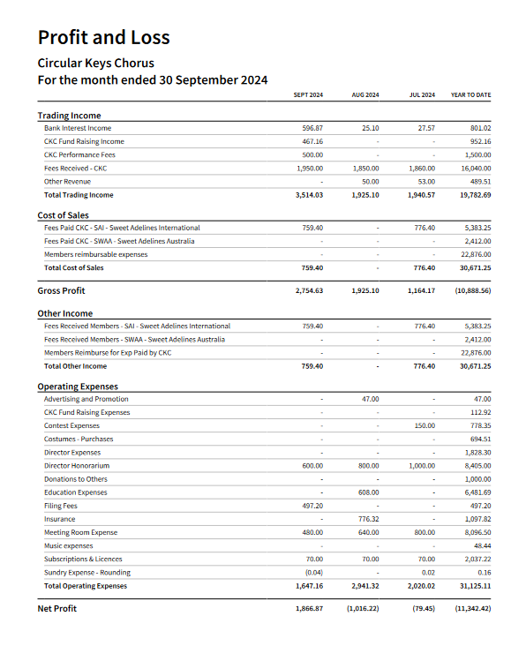

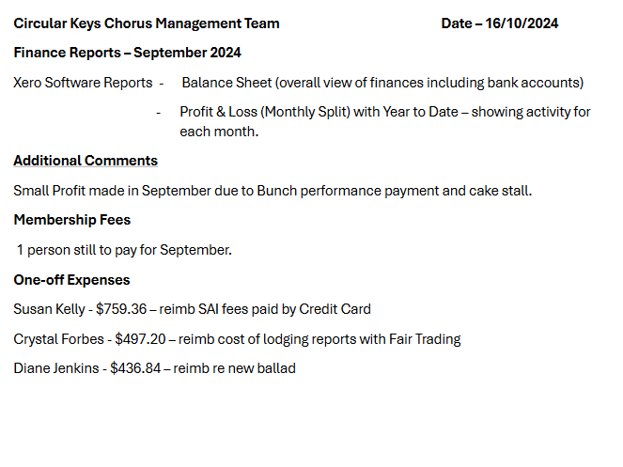

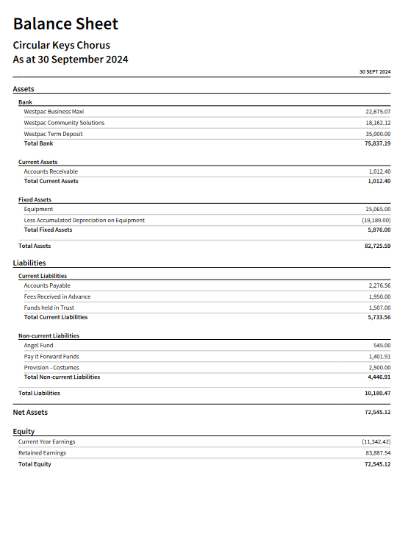

Music Report – October, 2024

Music team have not had a meeting since contest. This is problematic for making team decisions even though I have continued to communicate decisions with the team, there is no opportunity to have shared discussions. I am looking to change things up to try and remedy the situation however with so many chorus members away at the moment, including music team members, it is very difficult to make changes without people feeling like they’re being ‘punished’ – which is not my intention at all. I will hold over making changes until the new year however I am just flagging the situation and to advise management that I am not satisfied with how things currently stand.

Upcoming performances –

Working through the Christmas rep in rehearsals, hoping to get as many ‘up to speed’ on the material as possible.

Assessment/qualification for Christmas performances -

* The first time a member has to pass an Xmas song once, it should be done by audio recording, but after that members can pass by attending a section rehearsal, or by performing in a small chorus during rehearsal, or a by live riser.
* That members can hold sheet music as long as they only need to refer to it occasionally
* For newer members, have a short list of songs for them to learn, and we can group those songs together in one set (yet to be determined however would include the songs we have been working on already).

Contest rep for next year –

The arranger, Adam Scott has advised he is working on our ballad and should have it ready for us by the end of October. As soon as I get back, I will get started on the learning tracks.

Re uptune – I want to wait until after international in case I hear something that is spectacular that I want for us.

In the meantime, I am playing with our arrangement of “All The Things You Are” to turn it into a swing uptune.

Possible August/September show for 2025 –

Waiting to hear back from the quartet “Midtown” who will be headlining the BHA national contest in Canberra in September. Current correspondence has asked if they can arrive in Sydney the weekend before the contest so they can headline a show at the Hornsby RSL along with Sydney Harmony and Circular Keys. The date would be Saturday, August 30th. If they can’t come earlier, then it would be two weeks later, 13th September. Midtown have indicated interest and now just waiting for them to figure out what they can do. This would be a jointly managed show between SHC and CKC with all proceeds shared. I do not know what Midtown will charge yet. No contact has been made with Hornsby RSL yet to check dates.

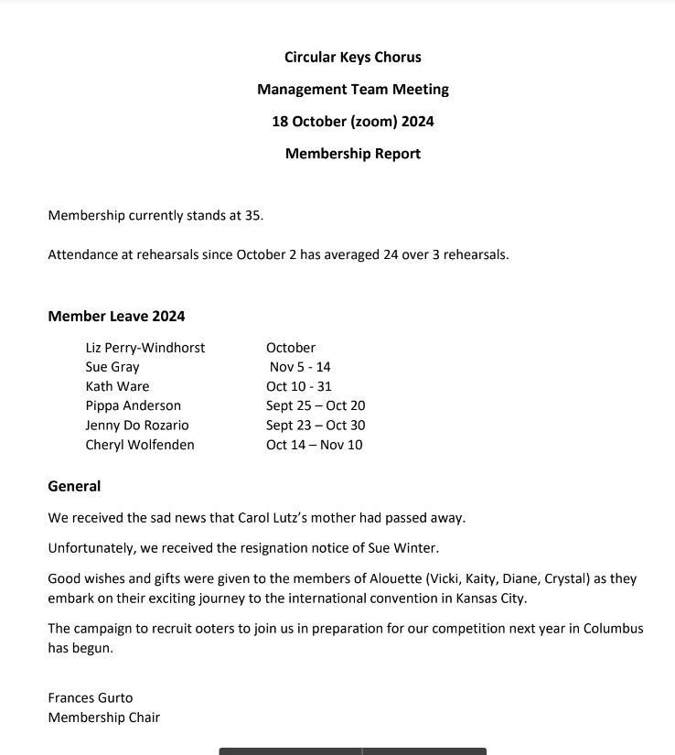

Management Team Meeting

Friday 18 October 2024

PR &amp; Marketing Report

By Jen Kumar

• We launched our Ohio – Here we go! campaign and logo.

• Ohio – Here we go! first monthly email was well received and created discussion and enthusiasm.

• Communicated in social media over our 3 sites.

• Also launched our Ooters and dual members campaign over our 3 sites and instagram, which was also shared by many members and has already created several responses.

• Proposed chorus business card to be shown to give out at performances for new members and new paid event work.

• Planning on signage designs for next month.

PERFORMANCE

Performance Report October 2024

City of Sydney – Choirs in the City

Performance agreements for this event have been signed and returned to the event organiser.

Sydney Cats and Dogs and Cats Home

We have received an inquiry regarding a possible performance at their Santa Paws fundraiser on

29/11-1/12. They are raising funds for a new shelter in Kurnell. This is an unpaid performance and as

such they are flexible as to how long we perform for. Details for the event are still being finalised and

they will contact me when they have further information.

Hills Shire Council – Australia Day Celebrations

I have received an email regarding expression of interest for this event. The form is due by 15th

November 2024. The performance will be unpaid, 10 minutes, max. 15 people on stage, at Bella Vista

Farm. Time allocations are 4.30-5.30, 5.30-6.30, 6.30-7.30pm.