CKC Management Team Zoom Minutes Friday 22nd November 2024

**Chairperson:** Rachael Moessis

**Minutes:** Anne Harris

| **Item**  **No.** | **Item** | **Discussion** | **Action** | **By Whom** | **By When** |
| --- | --- | --- | --- | --- | --- |
| 1. | **Attendance via Zoom**  **Apologies**  **Meeting commenced:** | Chairperson Rachael Moessis  Secretary Anne Harris  Membership Frances Gurto  Treasurer Susan Kelly  Performance Jane Masters  Marketing/PR Jen Kumar  Team members  Director Vicki Dwyer  Pippa Anderson  Di Jenkins  Crystal Forbes  7.40pm |  |  |  |
| **2.** | **Acceptance of minutes** | Moved: Jane  Seconded: Frances |  |  |  |
| **3.** | **Business Arising** |  |  |  |  |
| 3.1 | Chorus Cultural project | Discussion that proposed mission statement included in last minutes was too long.  New statement **“We unite through music creating a harmonious space where voices blend, friendships frow and artistry thrives”.** Team members all in agreement. in agreement. | Include in next newsletter | Rachael | December |
| 3.2 | Update on Changes to NSW Incorporation Rules | Susan completed form for public officer and has received correspondence it has been received.  Chorus to vote on acceptance of NSW Incorporation Rules and changes. | Article in SCB  Voting | Susan  Rachael | Completed  Completed |
| 3.3 | Member recruitment/banners | Banner placements in Hornsby Shire.  “New singers always welcome” to be pinned on Instagram  Needing more chorus members- approach Macquarie Uni groups. | Investigate changeable banners  Instagram inserts  Invitation to singers | Jen  Jen  Vicki | Ongoing  ASAP  ASAP |
| 3.4 | IBOD voting | For whole chorus 6th November | Set up voting process | Rachael | Completed |
| 3.5 | Director’s School 2025 | Di now attending during the day only. |  |  | Completed |
| 3.6 | BHA Competition 2025 Eastern region Nationals | No further discussion -24/5 in Canberra |  |  | Hold over |
| 3.7 | Portfolios, Procedures and Handovers | Each committee member to compile a short list of the responsibilities and processes of their individual roles. |  |  | Hold over |
| 3.8 | CKC Christmas party | To be held on Wednesday 18th December  Social team organising  Request from Ann Keating to hold a raffle- all in agreement and to include Courtney, Kaity and Linda in the planning.  As part of fostering positive chorus culture a game was suggested that provides positive individual feedback using the shape of a Christmas tree with members writing affirmations.  Suggestion given that we support a not for profit this Christmas with cash or food instead of chocolates and gifts.  Member who has vision impairment to be approached before Christmas party to enable her to pre plan.  Suggestion of Ice breaker game - linking arms together | Send email to Ann  Print copies of Christmas tree outline  Blacktown Council re DV, homeless, Foodbank groups  Article to be put in SCB.  Feedback to planning committee | Jane  Frances  Jen  Rachael  Jen | ASAP  18th December  ASAP  ASAP  ASAP |
| **4**. | **Ohio planning** |  |  |  |  |
| 4.1 | Ooters/Brindabella Guide | Use of guide for CKC Ooters, add Sat/ weekend rehearsals. Saturday dates and venues discussed by Rachael.  Continue to advertise CKC Ooters for Columbus Ohio 2025.  We have had 6 potential Ooters wanting to join- including Sus Gaudie  Important for us to target individuals. Vicki to compile a list of other chorus directors to approach to extend the invite for Ooters. Also include her mixed chorus and Macquarie Uni singing group. We may need to attend the Uni groups to approach.  Discussion to approach ex members- Cheryl, Lyn, Barb, Vicki Sutton and Bev Hewitt and Emily | Adapt Brindabella guide for CKC  Facebook, Friends of CKC, Instagram  Provide feedback to Sue | Crystal  Jen  Rachael  Vicki  ??? | Hold over  Ongoing  ASAP  ASAP |
| **4.2** | Forward planning | ?? team to inspire members and Ooters  Newsletter articles  Di reports that she is in discussions with Scotsdale regarding rehearsal space - many thanks Di for looking co-ordinating this | Ohio newsletter in SCB | Rachael  Di | Ongoing  Ongoing |
| 4.3 | Dates for compulsory rehearsal attendance for Ohio | Monthly first Saturday rehearsals  Potential October family show discussed for 11th October. Venue options include Stanhope Anglican church and Life Anglican Church at Quakers Hill. | Check access to St Josephs  Contact Courtney’s mum through Courtney | Rachael  Rachael | ASAP  ASAP |
| 4.4 | St Joseph room hire, dates and spaces | Pacifica room booked for first Saturday of the month however it is not available 1st February and October. Rachael to book another room at St Josephs for February and 27th September.  Anonymous donor paying for weekend rehearsals at St Joseph’s- many thanks!! | Book room for Saturday reheursals | Rachael | ASAP |
| 4.5 | T- shirts and jacket options | Continue with black t- shirts and logo for Ohio which can be used for reheursals.  Discussion that it would be best that any jackets would have a CKC logo (not Ohio) enabling it to be used in a continual way.  Frances has recently purchased a jacket that maybe suitable and will supply details. | Email to Carol re jackets and emblem  Obtain jacket purchase details | Rachael  Frances | ASAP  ASAP |
| **5.** | **Correspondence** | 1. Chapter Membership Renewals Reminder 2. Confirmation of IBOD vote 3. Ongoing email with St Joseph’s re room availability 4. Dual member enquiries for 6 people- send basic information re audition process 5. Email re hospitality team needing more members 6. Confirmation from NSW Fair trading re public Officer | SCB article | Rachael | Next SCB |
| **6.** | **Ratifications** | None |  |  |  |
| **7**. | **Reports** |  |  |  |  |
| 7.1 | Financial | (See report below)  Accepted: Frances Seconded: Anne  This month the chorus made a profit mainly due to fund raising  New members need to fill out forms for International fee payment |  | Sue | ASAP |
| 7.2 | Music team | New arrangement from Adam Scott -Always on My Mind (ballad) has arrived. Vicki requested some changes to the introduction- completed.  Members listened to an initial recording of the ballad. Vicki hoping to have recording for all parts out by the end of the year.  Changes re music team. Vicki requested volunteers from the chorus at last weeks rehearsal to assist with riser checking.  Susan for offered to help with the lead section  Jane is considering helping with the bari section.  Training session available for using Audacity which assists with note accuracy. | Contact Adam Scott re arrangement | Vicki  Vicki | Completed  Ongoing |
| 7.3 | Membership | (See report below)  Now 34 members  Francis reports that new members need to pay International fees.  Deb attending occasionally.  Betty has been very unwell and feedback re her progress given by Rachael t the last rehearsal.  We were all proud to see Allouette perform at Kansas.- many congratulations.  Discussion re SAI mission retension for the month- “That’s what I like about you”. Decided not to enter into the competition but use the idea for our Christmas party. | Pay International fees  in January  Send card form chorus | Susan  Rachael | January  Completed |
| 7.4 | PR/Marketing | (see report below)  New business cards to advertise chorus- looking good.  Kath has suggested adding CKC Christmas Carol dates and Bunnings onto our social media.  Many thanks to Rahael for hosting Halloween and the “watch” party for Kansas. | Accepted with small correction  Add to social media | Jen  Jen | Completed  ASAP |
| 7.5 | Performance | (See report)  City of Sydney Carols.  Feedback given that a new member is wanting a list of Christmas songs to be sung. To check the website and learn the “definite” Christmas songs. Discuss with member the informal nature of the carol’s performance. This year another group will be singing when we have a break.  Sydney Cats and Dogs are looking for community groups for free performance in the Strathfield area.  Potential Australia Day gigs   * Bella Vista -15th November. Unpaid- not to continue.. * Parramatta council- contacted (new event manager) * Check with Blackton Council re any paid performance opportunity   A submission has been received from Lachlan from Sydney Community Radio Station ( 2SER) who is requesting an interview or attendance at our rehearsal for an upcoming radio program re Christmas music.. Discussed that Allouette and Jen could attend an interview. | Not at this time  Discussion with Vicki  Awaiting response  Awaiting response  Email sent to Lachlan | Vicki  Jane  Jane  Jane  Jen  Vicki | Next reheursal  Completed  Complete  Completed |
| 7.6 | Fund raising | Return and Earn bottles/can collection up and running-  Bunnings BBQ’s:  November 2nd and 7th December 2024  9th February and 12 April 2025.  Some onions left over and frozen. All the BBQ equipment is with Jane except the large eski.  Square for payments – easy to connect via blue tooth on Jane’s phone  Researching grants for chorus- Email received from Pippa that she is not able to co-ordinate grants at the moment.  Suggestion that Cathy be an information collector re what grants are available, what we would be eligible for and develop a grant calendar  New Paint and Sip at Tallawong | Article and QR code in SCB  Eski to Jane  Approach Cathy  Discuss with social committee | Rachael  Frances  Rachael  Jen | ASAP  ASAP  Hold over |
| **8** | **New Business** | None |  |  |  |
|  | Meeting closed | 10:50pm |  |  |  |
|  | **Next meeting 10th January 2025 7.30pm** | **Venue: Rachael’s 17 Cavendish Street Pennant Hills** |  |  |  |

REPORTS

FINANCIAL

Circular Keys Chorus Management Team Date – 20/11/2024

Finance Reports – October 2024

Xero Software Reports - Balance Sheet (overall view of finances including bank accounts)

- Profit & Loss (Monthly Split) with Year to Date – showing activity for

each month.

Additional Comments

October - Very small Profit.

Confirmation Letter received from NSW Fair Trading – 21/10/24 – re Public Officer appointment

November to date – Fund Raising Income - $2765

$5000 Donation received 20/11/24 to pay for room hire for additional rehearsals for

International. It will show in November Balance Sheet in Held in Trust - Other, to be kept for next

year.

Membership Fees

1 person still to pay for October.

5 Members still to pay for November.

Expenses

Diane Jenkins – 8/10/24 - $436.84 – reimb re new ballad & 1/11/24 - $200 - Director’s School

Rachael Moessis – 20/11/24 -$62 – Lodgement of changes to Rules of Incorporation

SAI Fees

8/10/24 - $759.36 – 4 members @ $189.85 per person

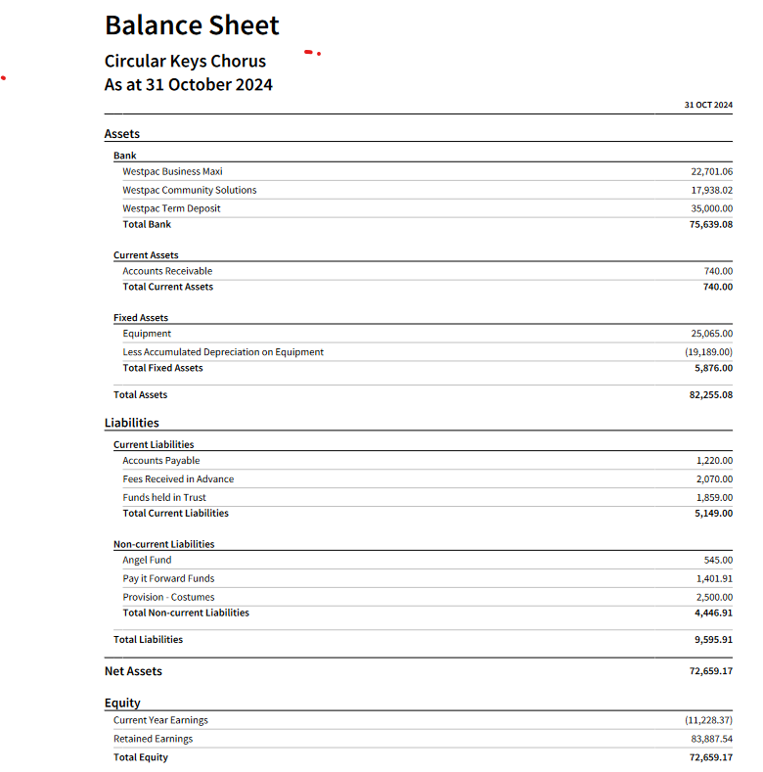

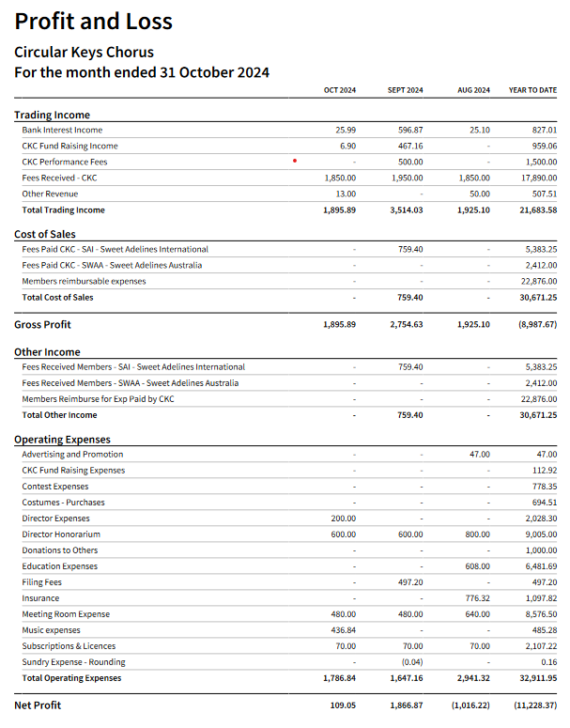

MUSIC REPORT – None

MEMBERSHIP REPORT

Circular Keys Chorus

Management Team Meeting

22 November 2024

Membership Report

Membership currently stands at 34.

Attendance at rehearsals since October 16 has averaged 25 over 3 rehearsals. As planned, no

rehearsals were held on October 23 and 30.

Member Leave

There are no members currently on planned leave. We will presumably be notified in the

new year of 2025 leave.

General

Unfortunately, we received the resignation notice of Liz Perry-Windhorst.

We have received notices from 3 singers who plan to join us as ooters in Ohio next year.

Betty Fuller is still quite unwell and has been struggling for some time, but we hope that her recent

surgery will improve her health.

We were very proud and excited to hear Alouette performing so wonderfully at the Kansas City

Convention. Hopefully they continue their journey into 2025.

The chorus has been enjoying brushing up on our Christmas repertoire and we look forward to

entertaining Christmas shoppers at our gigs in the city. The Bunch also has a performance on

December 19 at the Mark Donaldson VC Retirement Home.

Frances Gurto

Membership Chair

PR/MARKETING

Circular Keys Chorus

Management Team Meeting

Friday 22 November 2024

PR &amp; Marketing Report

By Jen Kumar

• Gift presentation for Alouette for international competition – picture and well wishes for

Alouette, Skylark and Endeavour shared on social media. Plus follow up congratulations

posts.

• Halloween and Watch Party posts – shared on socials, and pictures submitted to SAA comp.

Thanks Frances!

• Kath Ware has been working on article for SAA Ozcords – 2024 review plus ooters and duel

members call out. Thanks Kath!

• On social media – plan to list Christmas Carol dates and Bunnings BBQs for followers.

• Proposed chorus business card – presented for meeting.

• Planning on signage designs – to come.

PERFORMANCE

Performance Report – November 2024

Choirs in the City –

*The call sheet for our first performance on the 29 th has been forwarded to members.

*There was a slight concern regarding numbers for the 12 th and 16 th December

performances, however we now have a better balance of tenors and leads attending.

* Rachael is the only pitch blower for the 1 st December performance. Which members can

we approach to have a go at doing this with Rachael?

Sydney Dogs and Cats Fundraiser – apology has been sent that we are unable to support

the event due to prior engagement.

Castle Towers performance enquiry – we were asked to name our fee for a three hour (20

mins on, 20 mins off), Christmas performance at Castle Towers Shopping Centre on an

unknown date (advised late November/December). As discussed with Vicki, I requested

$1500. The event organiser advised that they would be in touch, but I have not heard any

further from them.

Australia Day 2025–

*We have decided not to apply for the Hills Shire event, based on the experience last year.

* I have reached out to City of Parramatta and Blacktown CC expressing our interest in

performing at their Australia Day events. I am waiting to hear from them.

FUNDRAISING

Fundraising Report – November 2024

Bunnings Sausage Sizzles –

*We raised $1879 at our BBQ on 2 nd November.

*Planning is underway for the the 7 th December

*We have been offered two more bookings for 9 th Feb and 12 th April, with hopefully further

dates later in the year.

Christmas Raffle – Ann Keating has asked if she can organise a Christmas Raffle for the end

of year CKC celebration and would like the approval from the management team before

proceeding.