CKC Management Team Minutes Friday 7th February 2025

**Chairperson:** Rachael Moessis

**Minutes:** Anne Harris

| **Item**  **No.** | **Item** | **Discussion** | **Action** | **By Whom** | **By When** |
| --- | --- | --- | --- | --- | --- |
| 1. | **Attendance**  **Apologies**  **Meeting commenced:** | Chairperson Rachael Moessis  Secretary Anne Harris  Membership Frances Gurto  Treasurer Susan Kelly  Performance Crystal Forbes  Marketing/PR Jen Kumar  Team members  Director Vicki Dwyer  Pippa Anderson  Di Jenkins  7.55pm |  |  |  |
| **2.** | **Acceptance of minutes** | Moved: Frances  Seconded: Rachael |  |  |  |
| **3.** | **Business Arising** |  |  |  |  |
| 3.1 | Chorus Cultural project | Discussion with Jan Carley 14/1/25  Feedback that the time was beneficial to all.  Di ran a session at CKC last Saturday looking at identifying our individual strengths.  Next session will look at our mission statement in depth- firstly concentrating on respect and what behaviours support this. The exercises from Jan’s book will underpin the focus. | Segment in chorus rehearsal time looking at respect | Di | Next week |
| 3.2 | Member recruitment | Approach Macquarie Uni singing groups- it has been decided to leave this at the moment. | Invitation to singers | Vicki | Hold over |
| 3.3 | BHA Competition 2025 Eastern region Nationals | 24/5 in Sydney.  Rachael has been in touch with Richard,co-ordinator of the competition. He will pass her details through to the appropriate person. | Insert in CKC calendar  and SCB | Rachael | ASAP |
| 3.4 | Portfolios, Procedures and Handovers | Individual committee members to compile a short list of the responsibilities and processes of their individual roles that would be helpful for new committee members.  Set up new document section for committee portfolios on CKC website | Compose a short list  Document section in website | All committee members  Rachael/  Vicki | As possible |
| **4**. | **Ohio planning** |  |  |  |  |
| 4.1 | Ooters/Brindabella Guide | Adapted smaller version guide for Ooters. |  | Di/ Rachael | Completed |
| **4.2** | Forward planning | Assemble a team to inspire members and Ooters- leave at the moment and use information from Jan Carley’s session  Next newsletter article to include an upcoming time line e.g. when registration due, information re Emily in March 1/3/25  Accommodation package for Ohio.  Chorus members to fill out their requests.  Forms due back 12/2/25.  Confirmed Ooters  2 basses- Paula and Vicki  1 bari- Diane James  2 leads- Lynette and Bec  1 tenor- Sandy  .  Personal email invitation to past members to join us going to Ohio- decision not to proceed  Directors School -Vicki to request directors extend an invitation to their choruses to join us for Ohio  Digital DL flyer to be used for advertising. Looks great- many thanks Jen. Flyer to be added to the CKC website as well as On Keys site. | Ohio newsletter in SCB  Submit accommodation forms  Send email  Talk with chorus directors  Develop digital flyer  Insert flyer into website | Jen/  Rachael  Di  Vicki  Vicki  Jen  Jen/ Rachael | Ongoing  Completed  Completed  Completed  Completed  ASAP |
| 4.3 | Compulsory rehearsal attendance for Ohio | Monthly first Saturday rehearsals  Proceed with October family show 11th October  Time: 2-6pm  Venue: Richmond School  Cost of hall $280  Feedback from Crystal that it maybe difficult to have the risers on stage as there will a play set on stage.  Risers: discussion to borrow from Hills Harmony as they can be packed easily into a trailer.  Members to try to limit extensive travel before context - leave requests to go through Vicki. | Check access to St Josephs  Contact school re proceeding with booking  Request use of risers and person to transport from Hills Harmony  Article in SCB | Rachael  Crystal  Di  Rachael | Completed  As possible  Next SCB |
| 4.4 | St Joseph room hire, dates and spaces | Rehearse for Australian Day held at Crystals  1-22nd October not available at St Joseph’s.  Di liaising with Kellyville Anglican church re time available on either 1st, 8th or 15th October  Rachael has sent 2 emails to St Josephs re booking for 27-28th September (Bec’s coaching) and has had no replies. | Chorus members to attend  Contact church re date available  Ring St Josephs | Crystal  Di  Rachael | Completed  ASAP  ASAP |
| 4.5 | Jacket options | Continue research for jackets through Hills Uniform etc |  | Crystal | Ongoing |
| 4.6 | International Forms requirements | Housing forms for Contest- members have filled out their room requirements. |  | Di | Completed |
| **5.** | **Correspondence** | 1. 16/1: SAI: Monthly Renewal Notification 2. 22/1: SAI: Receipt 789062 3. 22/ and 30/1: Ann K: unable to access PhotoBucket 4. 2/2: Carol Lutz: Dual Members and CKC website- questions 5. 5/2: Richard Waddick: re BHA ER - he will check with Admin Judge re Invitational Choruses and let me know 6. 5/2: Kath Ware: Costume Storeroom Inventory and storeroom access policy 7. Various emails with Dual Members 8. Liaising with Diane Jenkins re Dual Members and Hotels 9. 7/2/25: Aurora Australis re use of risers 14-16th Feb |  |  |  |
| **6.** | **Ratifications** | None |  |  |  |
| **7**. | **Reports** |  |  |  |  |
| 7.1 | Financial | (See report below)  Accepted: Rachael  Seconded: Crystal  It was decided not to set aside money for costumes due to the chorus running at a loss last year.  One Ooter has paid the total amount requested, including make-up and costume.  Liaise with other Ooters re amount required  Resource make-up | Email to Ooters except Sandy  Buy makeup for Ooters | Susan  Vicki | ASAP  As possible |
| 7.2 | Music team | No report this month  To research songs appreciation with SAI/SDE song evaluation data base  For a music team meeting soon | Check data base  Nominate a date | Rachael  Vicki | ASAP |
| 7.3 | Membership | (See report below)  Now 33  Jane Masters now Chapter at Large  “Baby Come Back” contest with SAI.  Entries to be completed by 3/2/25- decide not to proceed with this  Next SAI promotion is for “Quartet Matchmakers”  SAA notified re update of all current and new members  Discussion re having member’s SAI ID added to CKC website | Notify SAI  Develop flyer and collate responses  Take photo and send  Email SAA  Request Carol to add individual ID | Frances  Frances/Jen  Vicki  Frances  Frances | Completed  Completed  Next rehearsal  Completed |
| 7.4 | PR/Marketing | (see report below)  Discussed the need for a flyer to be used for Directors/Ooters re CKC in Ohio.  New logo for CKC.  Thank you to Sue Gray for Australia Day posts | Develop flyer  Develop logo | Jen  Jen | Completed  Ongoing |
| 7.5 | Performance | No report this month  Send change of contact details from Jane to Crystal to Parramatta council. c/c Crystal  Australia Day gig with Parramatta council on 26th Jan. Payment not received - Crystal following up. | Email council  Email Parramatta council | Jane  Crystal | Completed  Completed  ASAP |
| 7.6 | Fund raising | Bunnings BBQ’s:  9th February - organised  12 and 21st April 2025  Bunnings requesting dates for next term- letter on CC letterhead to be sent  New Paint and Sip at Tallawong | Send CKC letterhead to Crystal  Email Bunnings  Discuss with social committee | Di  Crystal  Jen | Ongoing  ASAP  Hold over |
| **8** | **New Business** |  |  |  |  |
| **8.1** | CKC Storeroom and Costume Inventory | Comprehensive list received from Kath requesting what to keep or move on.  Red tops- move on  Purple and black- discussion they could be sold but decided to keep at the moment with the potential to use in the future- would need some adjustments for larger sizes to be made.  Purple pants- move on  Blue regional shirts- distribute  Purple polo shirts- throw out  Coral shirts- distribute  Dare to be Different shirts with bling- distribute  Uluru scarves- throw out  Firework scarves- Vicki to check  Old style shoes- throw out  New style shoes- distribute  Purple jackets- distribute  Fabric- teal and purple/black keep  green/ purple throw  Ear rings- keep teal and crystal and throw out others  Crocodile and kangaroo-  Historical books- keep  Accessing the storage room limited to costume co- Ordinator and fund raising co-ordinator (BBQ equipment kept in the storeroom) | Check with local school  Next SCB | Jen  Rachael | As possible  Next week |
| **8.2** | New Management Team member | Leave at the moment- Next AGM in April |  |  |  |
| **8.3** | Photobucket | Ann Keating has reported difficulties accessing PhotoBucket at last month.  Check to see if payment is up to date | Request Carol to follow up  Check payments | Rachael  Susan | ASAP  ASAP |
| **8.4** | Dual member access to website | Carol requesting clarification re access for dual members to CKC website.  Decision made to give access to the 2 new songs, SCB, Ohio documentation, next rehearsal program, performance program and events. Other songs and access can be made as needed.  Carol has set up an Ohio email address thank you Carol | Feedback to Carol | Rachael | ASAP |
|  | Meeting closed | 10.30pm |  |  |  |
|  | **Next meeting**  **7th March 2025 7.30pm** | **Venue: Rachael 17 Cavendish Street Pennant Hills** |  |  |  |

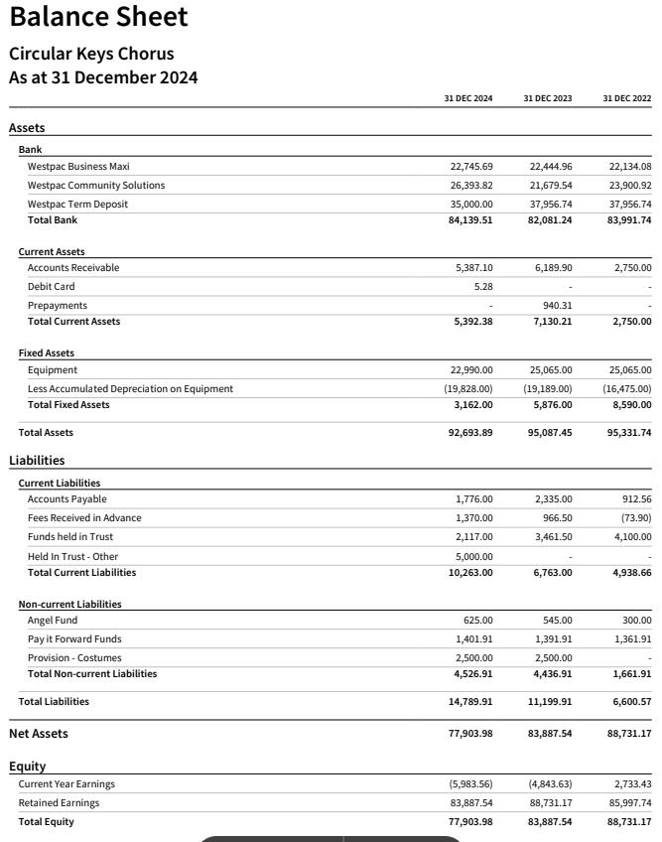

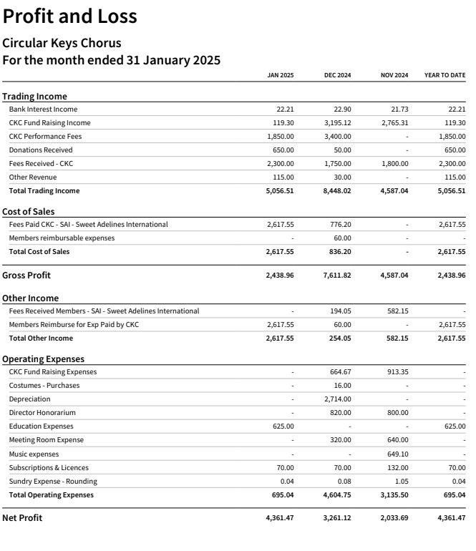

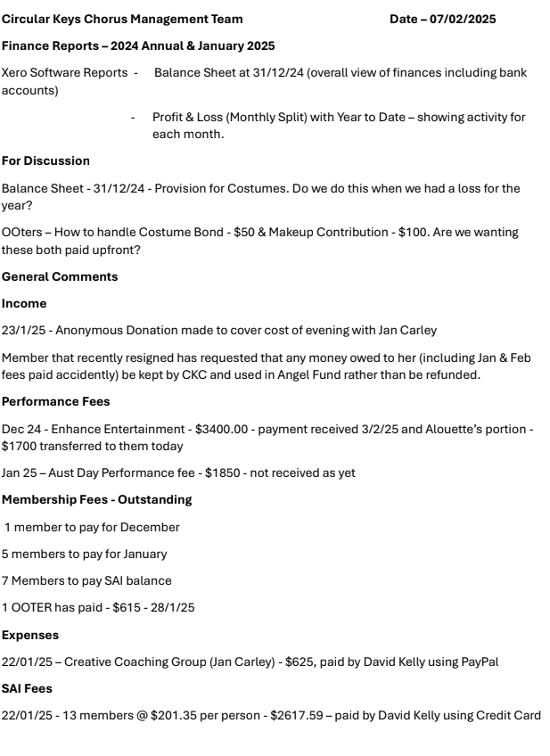

MUSIC REPORT

No report

MEMBERSHIP REPORT

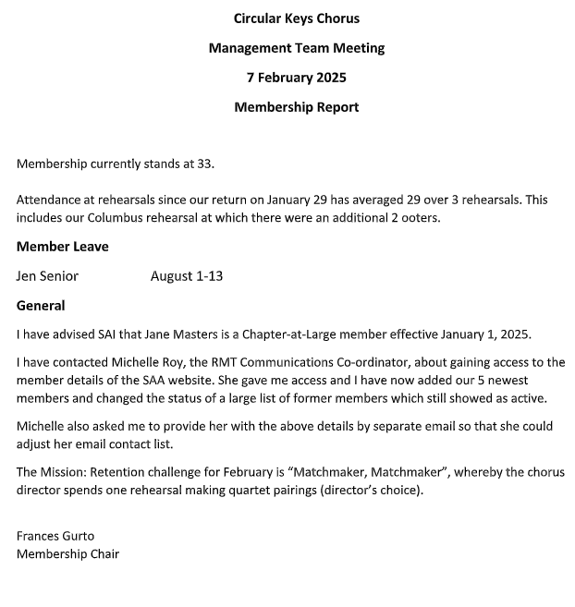

PR/ MARKETING

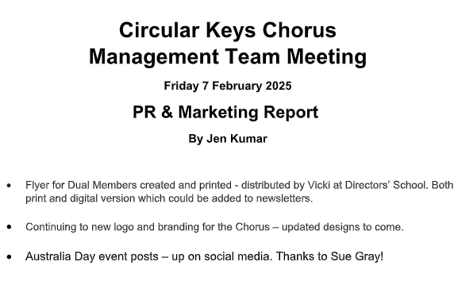

PERFORMANCE

No report

FUNDRAISING

No report