CKC Management Team Minutes Friday 7th March 2025

**Chairperson:** Rachael Moessis

**Minutes:** Anne Harris

| **Item**  **No.** | **Item** | **Discussion** | **Action** | **By Whom** | **By When** |
| --- | --- | --- | --- | --- | --- |
| 1. | **Attendance**  **Apologies**  **Meeting commenced:** | Chairperson Rachael Moessis  Secretary Anne Harris  Treasurer Susan Kelly  Marketing/PR Jen Kumar  Team members  Pippa Anderson  Director Vicki Dwyer  Membership Frances Gurto  Performance Crystal Forbes  Di Jenkins  7:52pm |  |  |  |
| **2.** | **Acceptance of minutes** | Moved: Susan  Seconded: Jen |  |  |  |
| **3.** | **Business Arising** |  |  |  |  |
| 3.1 | Chorus Cultural project | There have been 2 sessions during chorus rehearsals looking at respect and excellence. The next will be on commitment. A message from Di indicates these sessions will finish in 2 weeks, then the values will be consolidated.  Potential session with Sharon Cartwright on hold at the moment | Segment in chorus rehearsal time looking at committment | Di | Next week |
| 3.2 | Member recruitment | Approach Macquarie Uni singing groups- leave this at the moment. | Invitation to singers | Vicki | Hold over |
| 3.3 | BHA Competition 2025 Eastern region Nationals | 24th May in Sydney.  Update- the contact person now on BHA website is Tony Sykes. Contact to be made for further information. | Insert in CKC calendar  and SCB  Email Tony Sykes | Rachael  Rachael | Completed  As possible |
| 3.4 | Portfolios, Procedures and Handovers | Team members to compile short cheat list for positions that would be helpful for any incoming new committee members.  Can be added to Communication Area “Checklist for Incoming Committee”. | Compose a short list | All committee members | Ongoing |
| 3.5 | CKC storeroom and costumes | Crocodile and kangaroo props- Jen has contacted the school and is awaiting a reply. Options of different schools discussed.  Accessing the storage room limited to costume co- Ordinator and fund-raising co-ordinator  Old red costumes are being collected by Kath.  Costume items that were identified last meeting as not being required, to be distributed | Article in SCB  Article in SCB including photo of old shoes | Jen  Rachael  Rachael | Ongoing  Completed  Next SCB |
| 3.6 | Photobucket | Ursula has volunteered to organise - many thanks Ursula  Carol has fixed the access difficulties- many thanks Carol.  Members to send through any photos to Ursula/Photobucket  Susan reports that Sue Gray is happy to continue to be the contact person regarding payment for Photobucket- many thanks Sue. |  |  | Completed |
| 3.7 | Dual member access to website | Carol has organised Ooter access to CKC website. |  |  | Completed |
| **4**. | **Ohio planning** |  |  |  |  |
| 4.1 | Ooters and dual members | Confirmed Ooters  1 bass- Vicki  1 bari- Diane s  2 leads- Lynette, Bec, Susan  1 tenor- Sandy  Jen suggested sending a “thinking of you” tomorrow for International Women’s Day to those who may be affected by Cyclone Alfred- monitor cyclone situation.  Many thanks to Pippa for transporting Ooter to the airport | ? Social media comment | Jen | As possible |
| **4.2** | Forward planning | Next newsletter article to include an upcoming time line. Di to be contacted for further information.  Flyer to be added to the CKC website as well as On Keys site. | Email Di  Ohio newsletter in SCB  Insert flyer into website | Rachael  Jen/  Rachael  Jen  / Rachael | ASAP  Ongoing  Completed |
| 4.3 | Family Show | October family show 11th October 2-6pm at Richmond school  Risers: Hills Harmony will lend risers- thanks Di.  Volunteer needed to transport risers  Attendance at rehearsals before convention | Contact school re proceeding with booking  Risers obtained  Article in SCB | Crystal  Di  ??  Rachael | Hold over  Completed  Completed |
| 4.4 | St Joseph room hire, dates and spaces | 1st August, 27-28th September now confirmed for St Joseph’s | Ring St Josephs | Rachael | Completed |
| 4.5 | Jacket options | Continue research for jackets through Hills Uniform etc |  | Crystal | Hold over |
| **5.** | **Correspondence** | Received   1. 9/2/25: SAA Communications Coordinator: call for articles for Short & Sweet 2. 13/2/25: SAI Events Coordinator: International Convention process information, documents and forms 3. 13/2/25: SAI Janell Mason for Mary Rhea: Ann Gooch Award: information and forms 4. 13/2/25: SAI Events Manager: Ohio Tax Rate Update 5. 14/2/25: SAA Competition Coordinator: Region 34 Contest Registration information and links 6. 19/2/25: Bookings Team Saint Joseph's: confirmation of bookings for 1/8 and 28/9 7. 19/2/25: Bookings Team Saint Joseph's confirming all our extra International rehearsals and confirming Main Chapel for 7/6 8. 27/2/25: SAA Education Coordinator: Quartet Workshops for all members July/August 2025 9. 26/2/25: Co-Director Wollongong Harmony: re CKC's Angel Fund email (Rachael and Susan provided information by return emails   Sent   1. 18/2/25: Finance Coordinator SAA re our Wildcard entry to International (for SAA grant) |  |  |  |
| **6.** | **Ratifications** | None |  |  |  |
| **7**. | **Reports** |  |  |  |  |
| 7.1 | Financial | (See report below)  Accepted: Rachael  Seconded: Anne  Liaise with other Ooters re amount required.  Discussion re payment for Bec  Resource make-up  Riser loan payment still outstanding from Coastal a Cappella | Email to Ooters except Sandy  Buy makeup for Ooters  Send invoice | Susan/ Rachael  Vicki  Susan | Completed  Hold over  As possible  ASAP |
| 7.2 | Music team | No report this month  Draft form almost completed for ballad appreciation with SAI/SDE song evaluation data base. Rachael reports that the up tune is already on the data base.  Music team meeting | Check data base  Nominate a date | Rachael  Vicki | Hold over  Hold over |
| 7.3 | Membership | (See report below)  Now:37 including Ooters  Member’s SAI ID added to CKC website  Rachael discussed that we regularly touch base with those members who are not attending or on extended leave.  Longevity pins to be bought. The details for purchase are now on the SAA website. Rachael will contact Frances to proceed with purchase.  Susan requests that a screen spot of payment to sent to her to reimburse. | Request Carol to add individual ID  Buy pins | Frances  Frances | Ongoing  ASAP |
| 7.4 | PR/Marketing | (see report below)  Various examples for a new logo shown. Many thanks Jen for the work you are putting into this. |  |  | Ongoing |
| 7.5 | Performance | No report this month  Payment for Australia Day gig with Parramatta council  CKC performed for Crystal’s citizenship ceremony- many congratulations Crystal.  EOI form for performers at Blacktown Council completed. Thanks Crystal.  Rachael checked council site for gig payments 20 mins $200, 30 mins $300, 40 mins $400. For further discussion if gigs offered.  Rachael suggested option of busking at various venues e.g. Castle Hill Food Markets. She will research guidelines with local councils. | Email Parramatta council  Check with local councils | Crystal  Rachael | Completed  Hold over |
| 7.6 | Fund raising | Next Bunnings BBQ’s:12 and 21st April 2025  Bunnings requesting dates for next term- letter on CC letterhead to be sent  New Paint and Sip at Tallawong | Send CKC letterhead to Crystal  Email Bunnings  Discuss with social committee | Di  Crystal  Jen | Ongoing  Completed  Hold over |
| **8** | **New Business** |  |  |  |  |
| **8.1** | Extended leave guidelines | There has been discussion via email re options of reduced fees. To continue with normal fees for those on extended leave and have some flexibility in extenuating circumstances. |  |  | Complete |
| **8.2** | Doris Ward Award | Request has been put to chorus for nominations.  Thank you, Frances, for co-ordinating this. | Article in SCB | Frances/ Rachael | Ongoing |
| **8.3** | Standing rules/ management team decisions | At the moment there are no guidelines in our standing orders re extended leave guidelines- should this be written somewhere? |  |  | Hold over |
| **8.4** | Dual member update | (See Ohio planning) |  |  |  |
| **8.5** | Sharon Cartwright session update |  |  |  | Hold over |
| **8.6** | Song assessment/ song evaluation database update for contest songs | (see music team section) |  |  |  |
| **8.7** | CKC AGM | Proposed date 16th April. To be confirmed with rest of management members  3 management team positions for re nomination this year. Membership, performance and secretary. Discussion re the process for this including nomination team. | Email management team  Email management team members | Rachael  Rachael | ASAP |
| **8.8** | Emails on CKC Communication Area dashboard | Rachael has been in discussion with Carol. Emails can only be seen by those on the management team. |  |  | Complete |
|  | Meeting closed | 10:30pm |  |  |  |
|  | **Next meeting 4th April 2025** | **? via Zoom** |  |  |  |

FINANCIAL REPORT

Circular Keys Chorus Management Team Date – 05/03/2025

Finance Reports –February 2025

Xero Software Reports - Balance Sheet at 28/02/25 (overall view of finances including bank

accounts)

- Profit & Loss (Monthly Split) with Year to Date – showing activity for

each month.

For Discussion

Fees for Extended Leave

General Comments

Feb figures show a nice profit for the month but that includes $1700 from fund raising and $900

from Ooters who paid all their fees at once

Adjusting for these we have a loss of $520 for February but January was in profit - $4197 due to

Performance fees so we are a little ahead for a change.

Income

Performance Fees

Jan 25 – Aust Day Performance fee - $1850 – Paid

Other Revenue

Coastal a Cappella Chorus – use of risers – invoice sent but no payment

Membership Fees - Outstanding

2 members to pay for February

3 Members to pay SAI balance

Fund Raising

Bunnings BBQ - Net Profit of $1700

Donation – $100 for Fund Raising

Return & Earn - $40

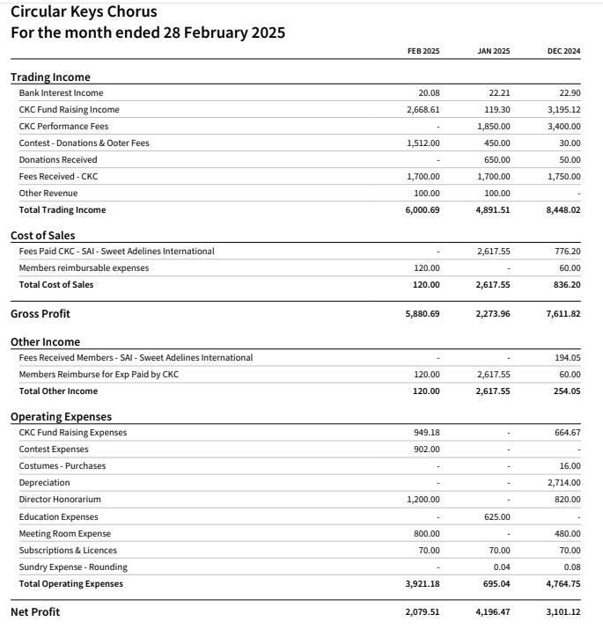

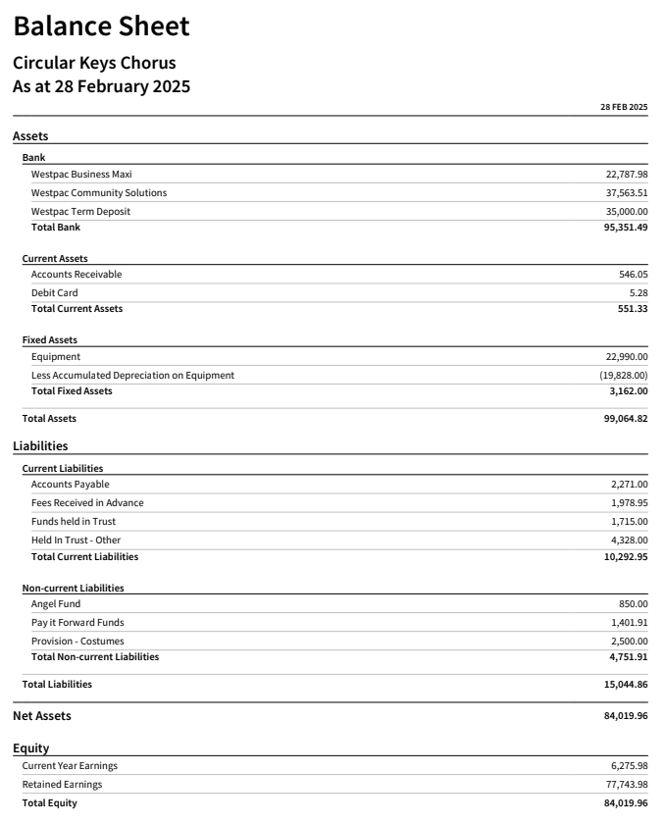

MUSIC REPORT

No report this month

MEMBERSHIP REPORT

Circular Keys Chorus

Management Team Meeting

7 March 2025

Membership Report

Membership currently stands at 37. This includes 4 ooters who have completed the Dual

Membership form.

Attendance at rehearsals since February 12 has averaged 30 over 5 rehearsals. This includes our

Columbus rehearsal on March 1 at which there were 3 ooters.

Member Leave

Jen Senior August 1-13

Frances Gurto May 24 – June 9

Heather Baeza and Emma Edwards are currently on extended leave/leave of absence.

General

I have sent the dual membership forms to SAI for Lynette Beech, Susan Pottie, Vicki Sutton

and Sandra Beath.

The Mission: Retention challenge for March is “Easy as 1, 2, 3”. The submission requirements have

not been released yet but have something to do with the number of new members desired. I

submitted our February entry and presumably we weren’t the winner!

Some longevity pins will be required for 2025. Can we please discuss. I have 2 10 year pins: some 25

year pins will be needed.

Frances Gurto

Membership Chair

PR/ MARKETING

Circular Keys Chorus

Management Team Meeting

Friday 7 March 2025

PR &amp; Marketing Report

By Jen Kumar

• Good to hear the Flyer for Dual Members (physical and online) secured some

new dual members for Ohio.

• See attached the latest version of logo and branding for the Chorus for

discussion – an interchangeable system with features on black.

• Good to see positive outcomes with Crysal’s Australian Citizenship

performance. Open for discussion on options of publicity from it, other than

social media.

• Thanks so much for Kath Ware for her website article!

PERFORMANCE

No report this month

FUNDRAISING

No report this month