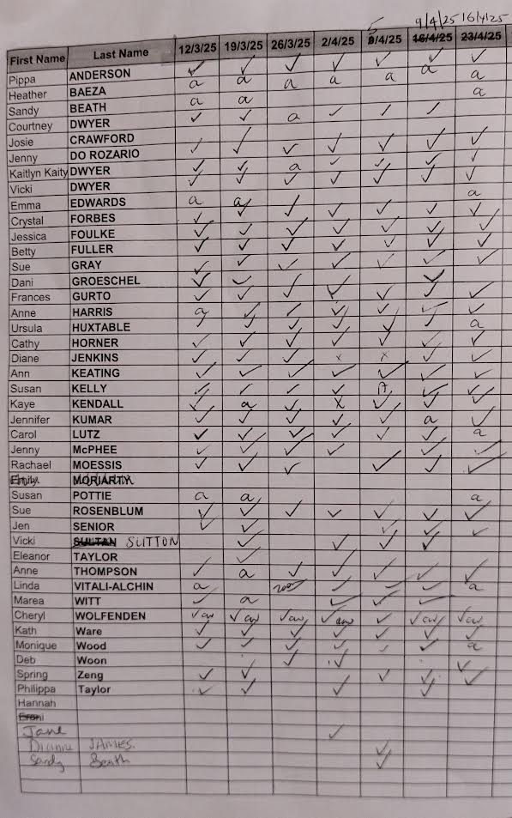

Carol Lutz attended via FM live stream