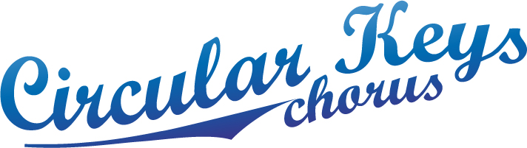

July 2014

We have two performances booked, and one expected ‘contra’:-

- Tuesday 29th July – City of Sydney Xmas Vision
- QVB contra for photo shoot December 2013
- Probus Parramatta Monday am 9th Feb 2015

Re performance for incoming members following membership drive 27 August to 17 September, with possible dates 21st or 28th September:-

I have spoken to the organiser of the Hills Orange Blossom Festival, and was told that our format does not fit into their theme this year, which is one of individual buskers.

I have emailed Loretta (lbabbage@parracity.nsw.gov.au) at Parramatta Council re their event schedule, and will follow up on this.

I spoke to Alan Jones from Kellyville Probus (9651 4521 alanjones@netspace.net.au
), who is now running Jazz at the Pines. He is interested in having us as perform as guests enter from the carpark to the venue. I am to send him details and await his response.

I suggested the possibility of singing at Castle Towers in an email to Vicki.

- We have also been asked by David Ojerholm from Sydney Harmony if we would perform on Sunday afternoon, 7th December, at St. Mary’s Church, North Sydney as part of a fundraising event for St. Mary’s Parish. This would be an unpaid performance.

Judith Bourne
Performance Coordinator

