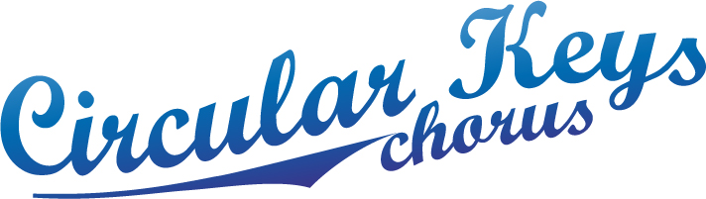

December 2014
Christmas performances:-

- Parramatta Council
We had a successful performance for Parramatta Council on the 27th November for the Kids’ Christmas Concert.

- Farmers’ Market
We will be singing at the Farmers Market Castle Hill Saturday 13th December, 8.00 am to 10.00am for a fee of $300.I doubt that this is a suitable venue for selling raffle tickets; I have asked twice and not had a reply.

- Australia Day 2015
It has been a boon to get into the glare of Parramatta Council’s headlights. Following on from the Kids’ Concert, we received an invitation to submit a proposal for Australia Day 2015, with which Alison is dealing.
Alison will advise MT re music, times, fee etc.

- Westfield Parramatta
This fell in a heap. Price too high? Barb said Endeavour sang for Westfield Miranda, 13 singers, 3 hours, $750. Maybe we need to drop our price? Quoted $1000.

- St Mary’s Church performance was enjoyed by all who attended on 7th December. Gorgeous singing by other choruses.

- Bunch of Keys: this appears to have been a successful enterprise by the chorus. Following on from carolling at Balcombe Heights, the Bunch was asked if they would consider a paid performance in Autumn 2015.

- I would like the MT, Music Team & Bunch of Keys to consult re moving forward with my proposal to obtain SAN sponsorship. It occurs to me that the Bunch of Keys would be able to perform a vital role in this endeavour, with especial regard to daytime performances. If approval is given, then I will liaise with Kate to develop a presentation.

- We currently have Probus as a performance event, more to come on that in the New Year.

Judith Bourne
Performance Coordinator

