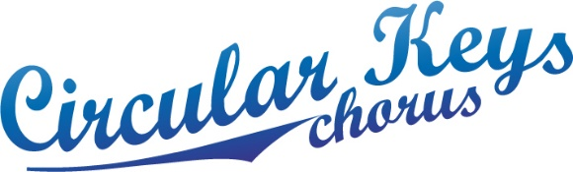

**Performance Coordinator’s Report for 2015 AGM**

The chorus performed at the following events:-

* 9th May 2014 Polio Australia at St Josephs
* 22nd June 2014 Sydney Harmony Concert at the Independent Theatre
* 15th July 2014 City of Sydney Xmas Vision, Sydney Town Hall
* 27th Nov 2014 Kids’ Christmas Concert for Parramatta Council
* 7th Dec 2014 Christmas Concert at St Mary’s Church, North Sydney
* 13th Dec 2014 Castle Hill Farmers Market
* 26th January 2015 Australia Day Parramatta Park
* 9th Feb 2015 Probus Parramatta Anniversary, Northmead

A number of chorus members attended additional daytime rehearsals under the aegis of Steph Wallbank and Doris Ward, and entertained various nursing homes.

Looking forward, we hope to raise our voices in glorious harmony at various venues where women congregate, in order to assist with our membership drives i.e. Women’s Day at local Golf Clubs, Probus events, Open Day at local Universities, and local markets such as Castle Hill & Lovers Market, Parramatta. Other areas to investigate are hospitals within our membership locale, future gigs for Parramatta Council, as well as focusing on obtaining as many Christmas performances as we can manage.

Warm thanks go to all who have stood shoulder to shoulder, bust to bust, in a variety of locations, enabling each of us, as well as the wider community, to enjoy the fruits of our vocal endeavours.

Judith Bourne